Synopsis

Olympic Performance Prediction Using Machine Learning
Problem Id: 26
STATEMENT: Design and develop an end-to-end machine learning system to analyze and predict Olympic Games performance using numerical sports data. The project involves selecting a suitable Olympic dataset containing features such as athlete participation counts, medal totals, event statistics, and country-wise performance across multiple years. Data preprocessing techniques including data cleaning, normalization, and transformation are applied to ensure consistency and reliability of the data. Exploratory Data Analysis is performed to analyze medal distributions, participation trends, and performance variations across countries and time periods using statistical summaries and trend analysis. Visualization techniques such as bar charts, line plots, and heatmaps are used to understand long-term performance patterns and relationships between variables. Correlation analysis is conducted to identify key factors influencing medal outcomes. Based on insights obtained from EDA, relevant features are selected to improve model performance (PCA, Forward Selection, Backward Selection). Machine learning models are then developed to predict medal counts using regression techniques or to classify countries into performance categories such as high, medium, or low performance. The trained models are evaluated using appropriate performance metrics (F1 score) to assess their predictive effectiveness, demonstrating a complete machine learning pipeline from raw sports data to evaluated predictive models.

Student Details:
- Vansh Kadiyan - University Roll No: 2028512 | SEC-G
2. Aarav Fangalia - University Roll No: 2028604 | SEC-G
3. Hrimandeep Singh - University Roll No: 2028429 | SEC-G

- Problem Description:
This project focuses on analyzing Olympic Games data and predicting country-wise performance using machine learning techniques. The Olympics involve multiple countries competing across various sports, where performance depends on factors like athlete participation, past performance, and event-level statistics. By analyzing historical data, patterns can be identified that influence medal outcomes. This system aims to help understand these patterns and build predictive models that estimate medal counts or classify countries into performance categories. In real life, such systems can assist sports authorities in planning strategies, allocating resources, and improving training programs. It also demonstrates how data-driven approaches can be applied in sports analytics for better decision-making.

- Steps of Implementation:
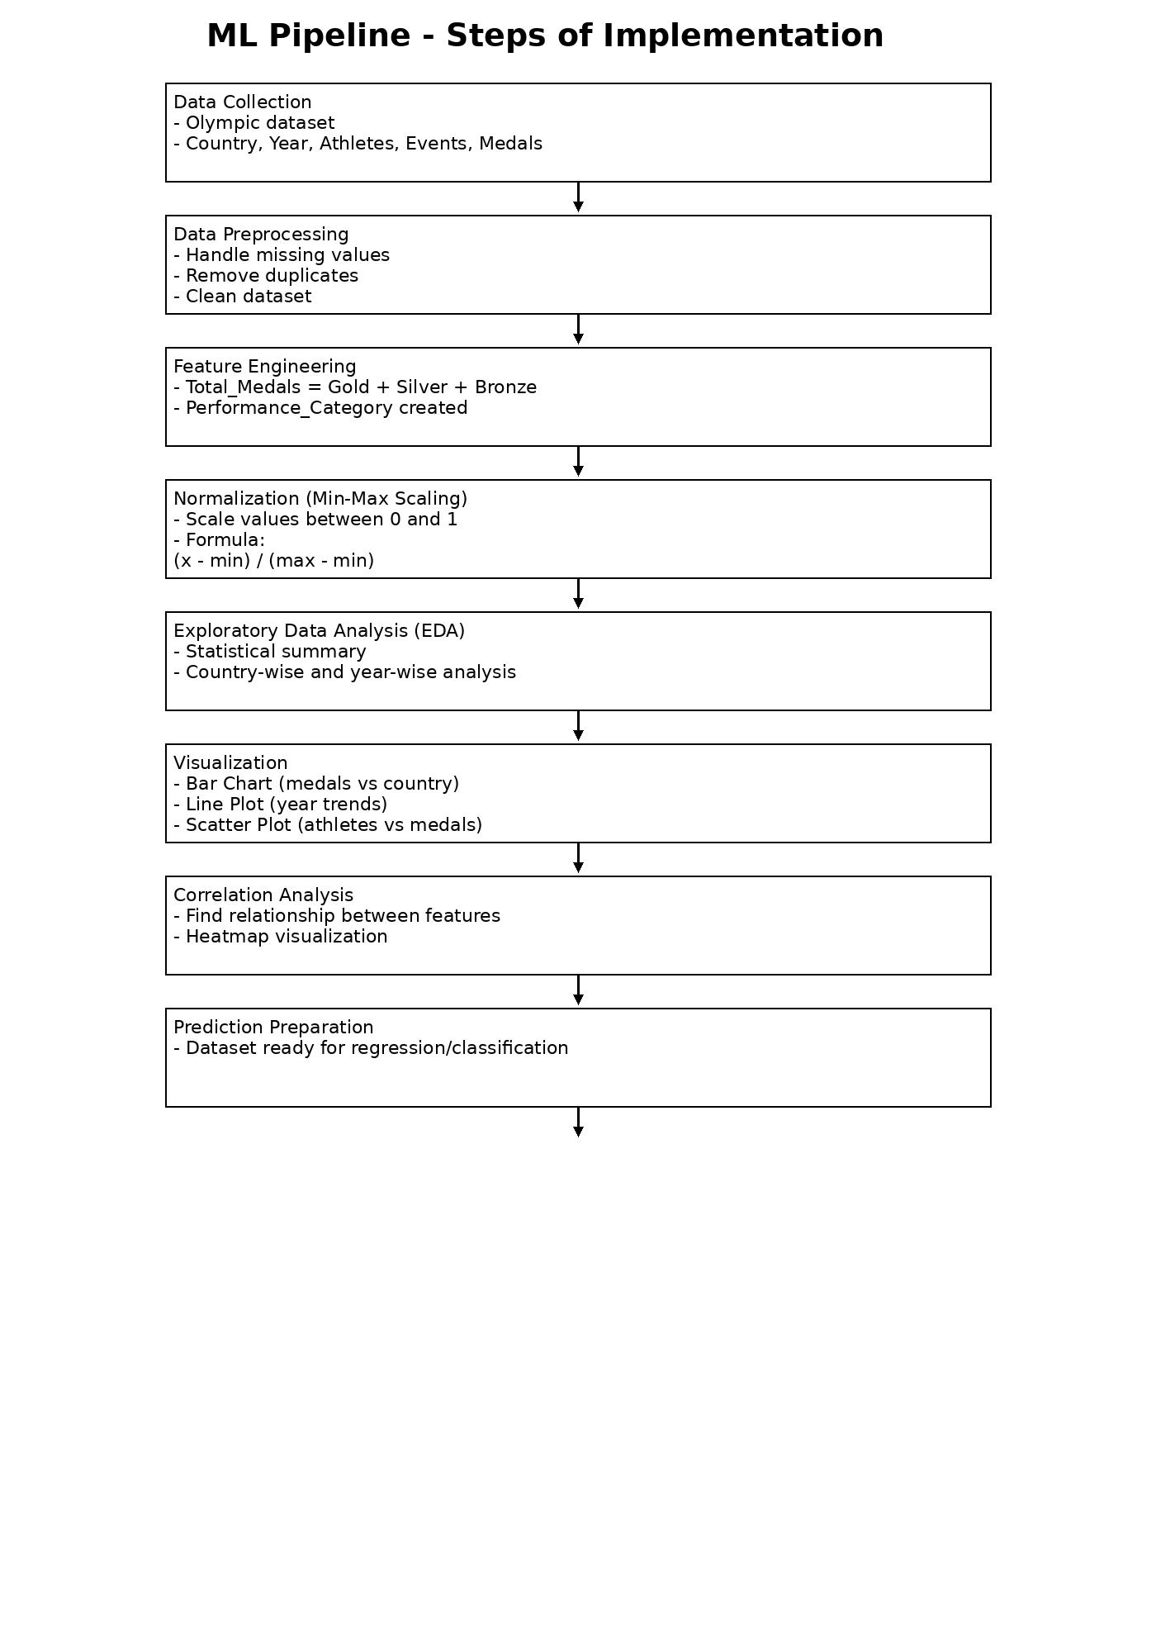

- Expected Modules/ Libraries to be used :
1. Pandas
Used for data handling and manipulation. It helps in creating Data Frames, cleaning the dataset, and performing preprocessing operations.
2. NumPy
Used for numerical computations. It is helpful in performing mathematical operations such as normalization and calculations on data.
3. Matplotlib
Used for data visualization. It helps in creating graphs such as bar charts, line plots, and scatter plots for better understanding of data.
4. Built-in Python Functions
Used for basic programming operations such as loops, conditions, and data processing.

5. Custom Functions
User-defined functions are used to create new features such as performance categories and to simplify code structure.

- Expected Evaluation metrics and Plots to be used:

🔹 Evaluation Metrics
1. Accuracy
Accuracy is used to measure the overall correctness of the model by comparing the number of correct predictions to total predictions. It helps in understanding how well the model performs in general.
2. Precision
Precision is used to measure how many of the predicted positive results are actually correct. It is important when we want to reduce false positive predictions.

3. Recall
Recall measures how many actual positive cases are correctly identified by the model. It is useful when missing important predictions needs to be minimized.

4. F1 Score
F1 Score is the combination of precision and recall. It provides a balanced measure of model performance, especially when data is uneven.

🔹 Visualization Plots
1. Bar Chart
Bar charts are used to compare medal counts across different countries. This helps in identifying top-performing countries.
2. Line Plot
Line plots are used to show performance trends over different Olympic years. It helps in analyzing improvement or decline in performance.
3. Scatter Plot
Scatter plots are used to analyze the relationship between two variables, such as athlete participation and total medals.

4. Heatmap (Correlation Plot)
Heatmaps are used to visualize relationships between different features. It helps in identifying which factors strongly influence medal counts.

- Required topics from the subject:
1. Data Structures (Arrays / Lists)
Data structures are used to store and manage the dataset efficiently. Lists and arrays help in organizing data in a structured format for processing and analysis.
2. Functions
Functions are used to break the program into smaller reusable parts. They help in improving code readability and are used for tasks like creating features and performing calculations.

3. File Handling
File handling is used to read and write data from files such as CSV files. It allows storing datasets and loading them into the program for analysis.

4. Conditional Statements (if-else)
Conditional statements are used to make decisions in the program. They are used for tasks like creating performance categories based on medal counts.\

5. Loops (for / while)
Loops are used to repeat operations on data. They help in iterating through dataset values for processing and analysis.

6. Mathematical Operations
Mathematical concepts are used for calculations such as normalization and statistical analysis. These operations help in transforming and analyzing data effectively.

- Platform Required:
1. Jupyter Notebook
Jupyter Notebook is used for writing and executing Python code in an interactive environment. It helps in step-by-step implementation, data analysis, and visualization.
2. Python (IDLE / VS Code)
Python is the main programming language used for implementing the project. It provides simple syntax and supports libraries required for data analysis and visualization.

3. Operating System (Windows)
A Windows-based system is used to run Python programs and required tools smoothly.

- Books and Link Sources:
1. “Let Us Python” by Yashavant Kanetkar1
This book helped in understanding basic Python concepts like loops, functions, and data handling which were used in the project.
2. “Programming in Python” by Reema Thareja
Used for learning core programming concepts and practical implementation of Python programs.
3. Kaggle (https://www.kaggle.com)
Used for accessing real-world datasets such as Olympic data for analysis.
4. Matplotlib Documentation (https://matplotlib.org)
Used to understand plotting techniques for visualization like bar charts and line graphs.

